LAB – 3

Q1 - Write a UDP client-server program where the client sends rows of a matrix, and the server combines them together as a matrix.

Server.c-

#include<stdio.h>
#include<fcntl.h>
#include<stdlib.h>
#include<sys/socket.h>
#include<sys/types.h>
#include<netinet/in.h>
#include<arpa/inet.h>
#include<unistd.h>
int main()
{
int sd;
char buf[25];
struct sockaddr_in sadd,cadd;
//Create a UDP socket
sd=socket(AF_INET,SOCK_DGRAM,0);
//Construct the address for use with sendto/recvfrom... */
sadd.sin_family=AF_INET;
sadd.sin_addr.s_addr=inet_addr("127.0.0.1");//**
sadd.sin_port=htons(9704);
int result=bind(sd,(struct sockaddr *)&sadd,sizeof(sadd));
int len=sizeof(cadd);
while(1){
int m=recvfrom(sd,buf,sizeof(buf),0,(struct sockaddr *)&cadd,&len);
puts(buf);
}
return 0;
}

Client.c-

#include<string.h>
#include<stdio.h>
#include<stdlib.h>
#include<fcntl.h>
#include<sys/socket.h>
#include<sys/types.h>
#include<netinet/in.h>
#include<arpa/inet.h>
#include<unistd.h>
int main()
{
int sd;
struct sockaddr_in address;
sd=socket(AF_INET,SOCK_DGRAM,0);
address.sin_family=AF_INET;
address.sin_addr.s_addr=inet_addr("127.0.0.1");//**
address.sin_port=htons(9704);
char buf[25],buf1[25];
printf("enter buf\n");
while(1){
gets(buf);
int len=sizeof(address);
int m=sendto(sd,buf,sizeof(buf),0,(struct sockaddr *)&address, len);
}
return 0;
}

output -
client-
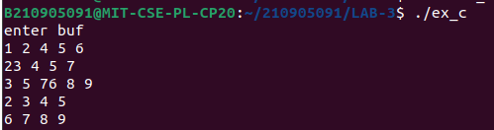
server-
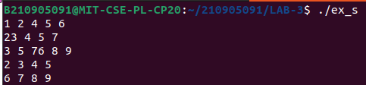
Q2 - Write a client program to send a manually crafted HTTP request packet to a Web Server and display all fields received in HTTP Response at client Side.

Client.c -

#define _XOPEN_SOURCE 700
#include <arpa/inet.h>
#include <assert.h>
#include <netdb.h>
#include <netinet/in.h>
#include <stdbool.h>
#include <stdio.h>
#include <stdlib.h>
#include <string.h>
#include <sys/socket.h>
#include <unistd.h>

int main(int argc, char** argv) {
char buffer[BUFSIZ];
enum CONSTEXPR { MAX_REQUEST_LEN = 1024};
char request[MAX_REQUEST_LEN];
char request_template[] = "GET / HTTP/1.1\r\nHost: %s\r\n\r\n";
struct protoent *protoent;
char *hostname = "google.com";
in_addr_t in_addr;
int request_len;
int socket_file_descriptor;
ssize_t nbytes_total, nbytes_last;
struct hostent *hostent;
struct sockaddr_in sockaddr_in;
unsigned short server_port = 80;

if (argc > 1)
hostname = argv[1];
if (argc > 2)
server_port = strtoul(argv[2], NULL, 10);

request_len = snprintf(request, MAX_REQUEST_LEN, request_template, hostname);
if (request_len >= MAX_REQUEST_LEN) {
fprintf(stderr, "request length large: %d\n", request_len);
exit(EXIT_FAILURE);
}

/* Build the socket. */
protoent = getprotobyname("tcp");
if (protoent == NULL) {
perror("getprotobyname");
exit(EXIT_FAILURE);
}
socket_file_descriptor = socket(AF_INET, SOCK_STREAM, protoent->p_proto);
if (socket_file_descriptor == -1) {
perror("socket");
exit(EXIT_FAILURE);
}

/* Build the address. */
hostent = gethostbyname(hostname);
if (hostent == NULL) {
fprintf(stderr, "error: gethostbyname(\"%s\")\n", hostname);
exit(EXIT_FAILURE);
}
in_addr = inet_addr(inet_ntoa(*(struct in_addr*)*(hostent->h_addr_list)));
if (in_addr == (in_addr_t)-1) {
fprintf(stderr, "error: inet_addr(\"%s\")\n", *(hostent->h_addr_list));
exit(EXIT_FAILURE);
}
sockaddr_in.sin_addr.s_addr = in_addr;
sockaddr_in.sin_family = AF_INET;
sockaddr_in.sin_port = htons(server_port);

/* Actually connect. */
if (connect(socket_file_descriptor, (struct sockaddr*)&sockaddr_in, sizeof(sockaddr_in)) == -1) {
perror("connect");
exit(EXIT_FAILURE);
}

/* Send HTTP request. */
nbytes_total = 0;
while (nbytes_total < request_len) {
nbytes_last = write(socket_file_descriptor, request + nbytes_total, request_len - nbytes_total);
if (nbytes_last == -1) {
perror("write");
exit(EXIT_FAILURE);
}
nbytes_total += nbytes_last;
}

/* Read the response. */
while ((nbytes_total = read(socket_file_descriptor, buffer, BUFSIZ)) > 0) {
write(STDOUT_FILENO, buffer, nbytes_total);
}
if (nbytes_total == -1) {
perror("read");
exit(EXIT_FAILURE);
}

close(socket_file_descriptor);
exit(EXIT_SUCCESS);
}

Output-
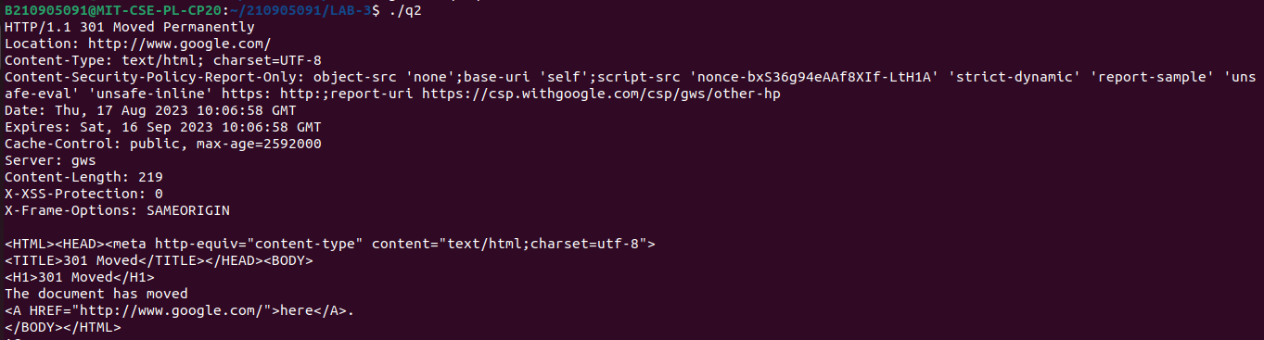
Wireshark -

A. In the packet list pane, select the first DNS packet. In the packet detail pane, select the User Datagram Protocol. The UDP hexdump will be highlighted in the packet byte lane.
Using the hexdump, Answer the following:
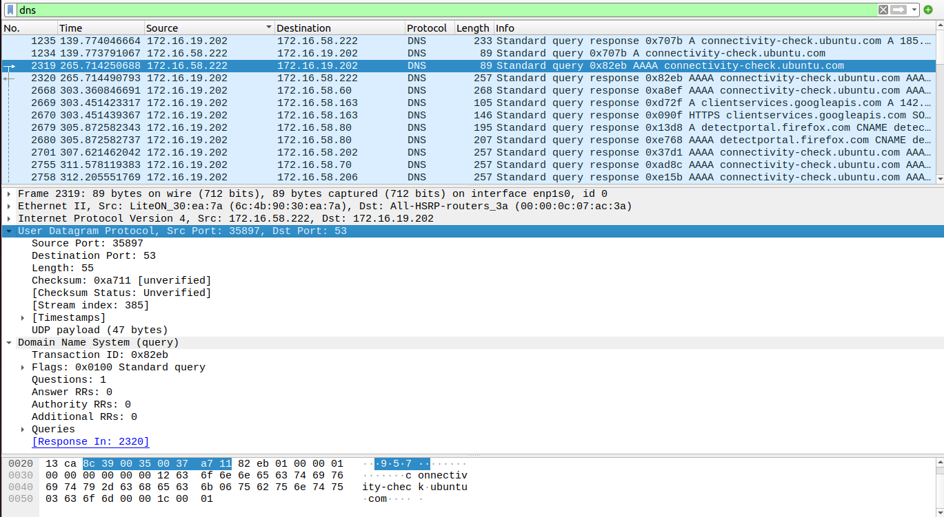
a. the source port number

Ans- 35897

b. the destination port number.

Ans - 53

c. the total length of the user datagram.

Ans – 89 bytes

d. the length of the data.

Ans – 47 bytes

e. whether the packet is directed from a client to a server or vice versa.

Ans – The packet is directed from client to server

f. the application-layer protocol.

Ans - DNS

g. whether a checksum is calculated for this packet or not.

Ans - The checksum is unverified for this packet.

B. What are the source and destination IP addresses in the DNS query message? What are those addresses in the response message? What is the relationship between the two?

Ans – The source ip is- 172.16.58.222 and destination ip is–172.16.19.202.
In the dns response, the source ip is – 172.16.19.202 and destination ip is 172.16.58.222. The client queries the dns server for a domain and the server replies with the ip address.

C.What are the source and destination port numbers in the query message? What are those addresses in the response message? What is the relationship between the two? Which port number is a well-known port number?

Ans -The source port is 35897 and the destination port is 53. For the response , the source port is 53 and destination port is 35897. The dns server accepts connections at port 53. Port 53 is a well known port.

D. What is the length of the first packet? How many bytes of payload are carried by the first packet?

Ans – Length of first packet is 89 bytes and size of the payload is 47 bytes.

2b. Analyzing TCP packets using Wireshark:

1. What are the socket addresses for each packet?
Ans- 172.16.58.222:49896 --> 13.33.144.60:80
2. What flags are set in each packet?
Ans- TCP Keep-Alive , ACK
3. What are the sequence number and acknowledgment number of
each packet?
Ans- Sequence no is – 433 bytes and acknowledgement no is - 866 bytes
4. What are the window size of each packet?
Ans- window size is 501 bytes.

1. What TCP flags are set in the first data-transfer packet (HTTP GET message)?
Ans- ACK,SET

2. How many bytes are transmitted in this packet?
Ans - 153

3. How often does the receiver generate an acknowledgment? To which
acknowledgment rule does your answer correspond to?
Ans- An acknowledgement is generated whenever a receiver receives a HTTP GET request .

4. How many bytes are transmitted in each packet? How are the sequence and acknowledgment numbers related to number of bytes transmitted?
Ans- 153 bytes are transmitted in each packet. Sequence no is the no op packets sent by the host and acknowledgement no is the no of acks sent by the receiver.

5. What are the original window sizes that are set by the client and the server? Are these numbers expected? How do they change as more segments are received by the client?
Ans- Original window size is 502 bytes. As more segments are received ny the client it can increase upto 64256 bytes.

6. Explain how the window size is used in flow control?
Ans- By reducing or increasing window size, the server and client each ensure that the other device sends data just as fast as the recipient can deal with it.

7. What is the purpose of the HTTP OK message in the data transfer phase?
Ans- That code represents a successful retrieval of the document ("OK"). If the server failed to retrieve the document, the status codes provide more information, like if the failure was due to user error or server error.

Part III: Connection Termination Phase

1. How many TCP segments are exchanged for this phase?
Ans – 4 tcp segments are exchanged for this phase.

2. Which end point started the connection termination phase?
Ans- The client started the connection termination phase

3. What flags are set in each of segments used for connection termination?
Ans- FIN , [FIN,ACK] , ACK

